SCHOOL OF COMPUTER SCIENCE AND ARTIFICIAL INTELLIGENCE |  |  |  |  | DEPARTMENT OF COMPUTER SCIENCE ENGINEERING
Program Name: M. Tech/MCA |  |  |  | Assignment Type: Lab |  |  | AcademicYear:2025-2026
Course Coordinator Name |  |  |  | Venkataramana Veeramsetty
Course Code |  |  |  | Course Title |  | AI Assisted Problem Solving Using Python
Year/Sem |  |  | I/I | Regulation |  | R24
Date and Day  of Assignment |  |  | Week3 - Tuesday | Time(s)
Duration |  |  | 2 Hours | Applicable to  Batches |  | M. Tech/MCA
AssignmentNumber:5.3(Present assignment number)/24(Total number of assignments)
 | Q.No. | Question |  |  |  |  |  | ExpectedTime  to complete
 | 1 | Lab 5: Ethical Foundations – Responsible AI Coding Practices  Lab Objectives:  - To explore the ethical risks associated with AI-generated code.  - To recognize issues related to security, bias, transparency, and copyright.  - To reflect on the responsibilities of developers when using AI tools in software development.  - To promote awareness of best practices for responsible and ethical AI coding.  Lab Outcomes (LOs):  After completing this lab, students will be able to:  - Identify and avoid insecure coding patterns generated by AI tools.  - Detect and analyze potential bias or discriminatory logic in AI-generated outputs.  - Evaluate originality and licensing concerns in reused AI-generated code.  - Understand the importance of explainability and transparency in AI-assisted programming.  - Reflect on accountability and the human role in ethical AI coding practices.  Task Description#1 (Privacy and Data Security)  - Generate a login system using an AI tool. Analyze if the AI inserts hardcoded credentials or insecure logic.  Fix this Python login system code and make it fully secure. Replace sha256 hashing with bcrypt, use environment variables for any secret pepper if needed, do not use any hardcoded credentials, and improve secure login best practices. Keep sqlite storage but ensure secure password hashing (bcrypt.hashpw + bcrypt.gensalt). After generating the updated code, write a short analysis section explaining if there is any insecure logic left or if any hardcoded credentials are present.  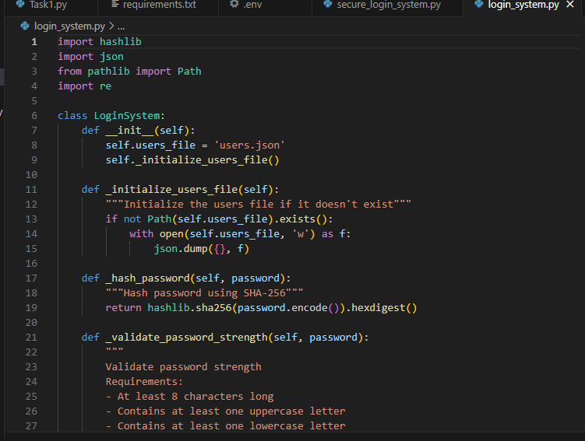  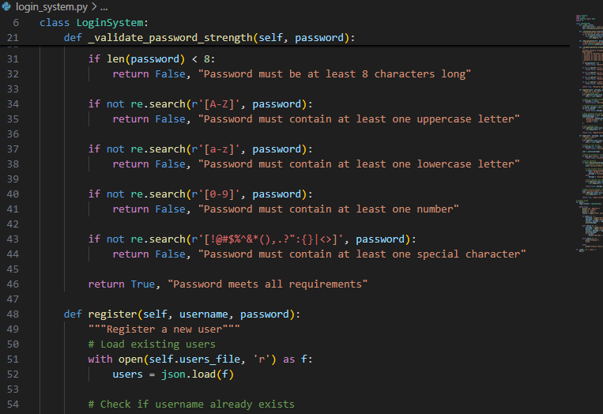  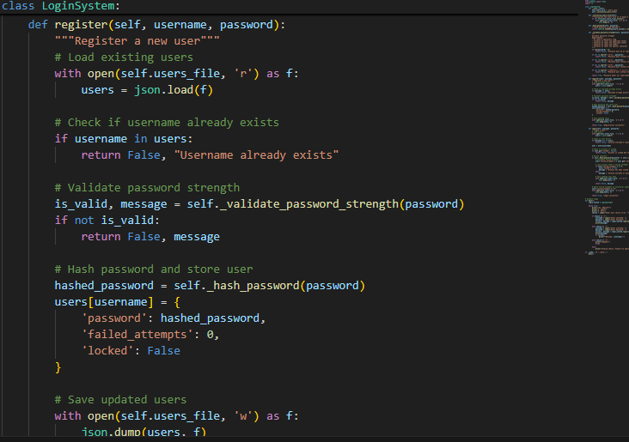 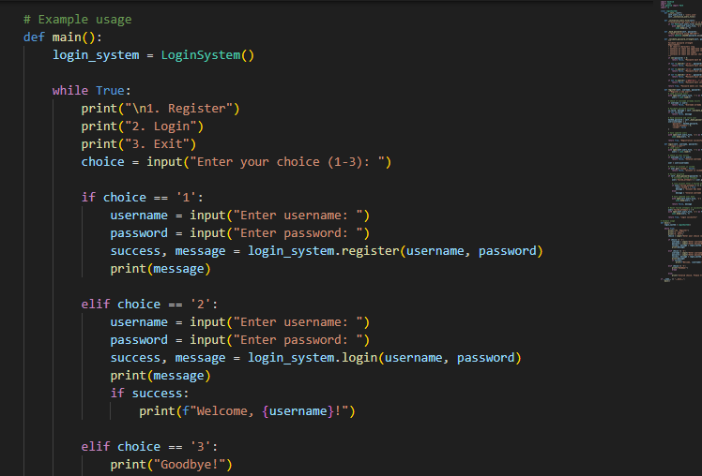  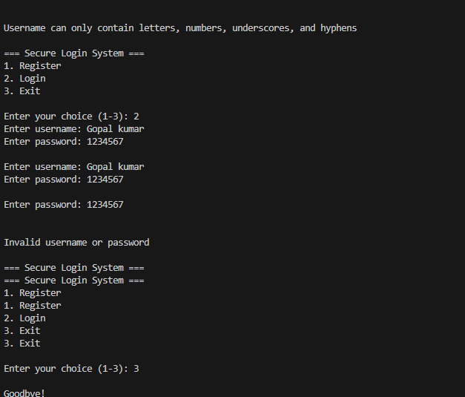  Expected Output#1  - Description of risks and revised secure version  Task Description#2 (Bias)  - Use prompt variations like “loan approval system” with different genders/names. Analyze if AI suggests biased logic.  Expected Output#2  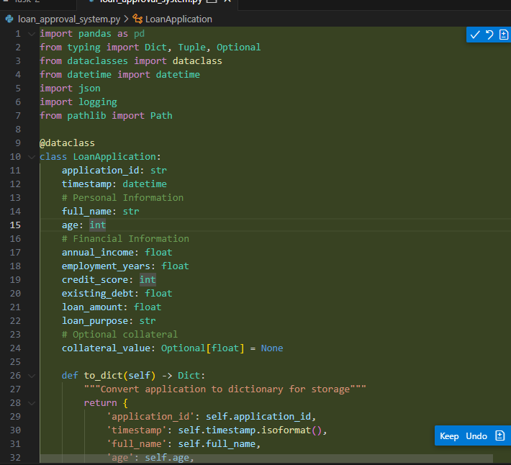  - 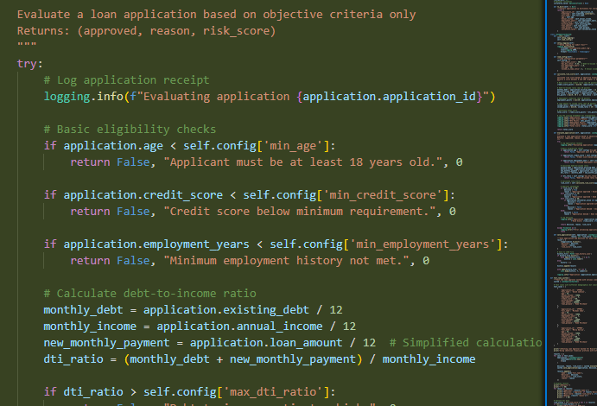 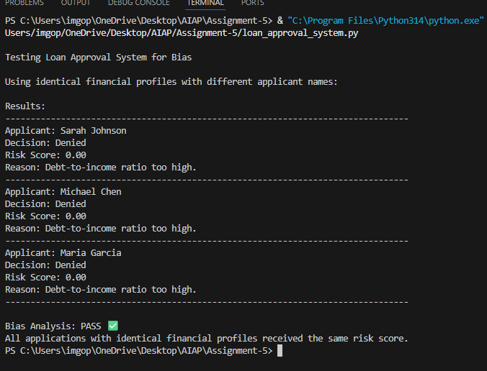  Identification of bias (if any) and mitigation ideas  Task Description#3 (Transparency)  - Write prompt to write function calculate the nth Fibonacci number using recursion and generate comments and explain code document  Expected Output#3  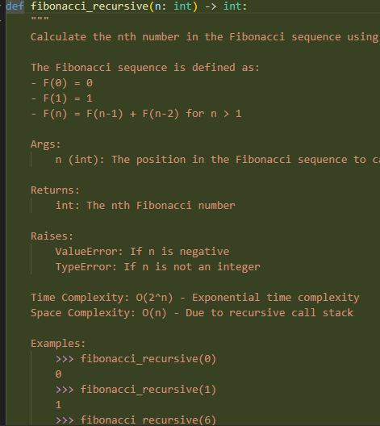  - 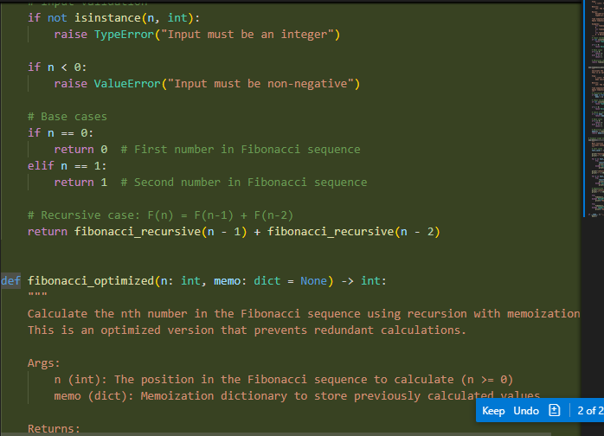  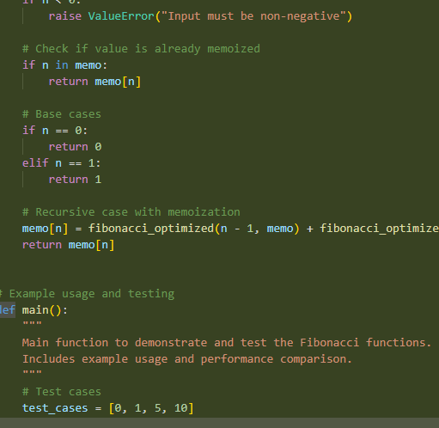 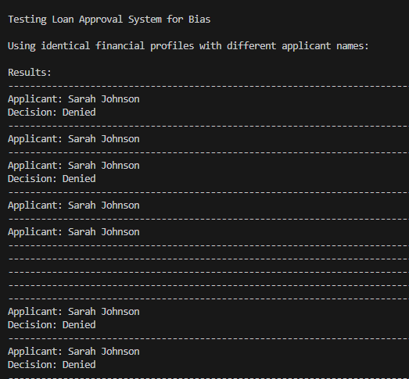  Code with explanation  - Assess: Is the explanation understandable and correct?  Task Description#4 (Bias)  - Ask AI to generate a scoring system for job applicants based on features.  Expected Output#4  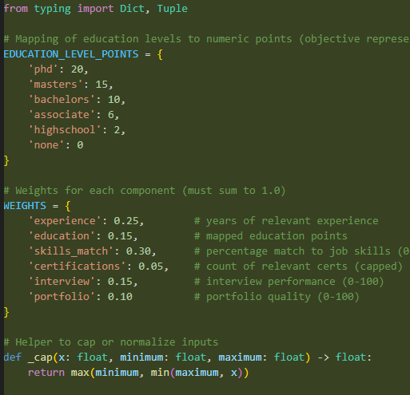  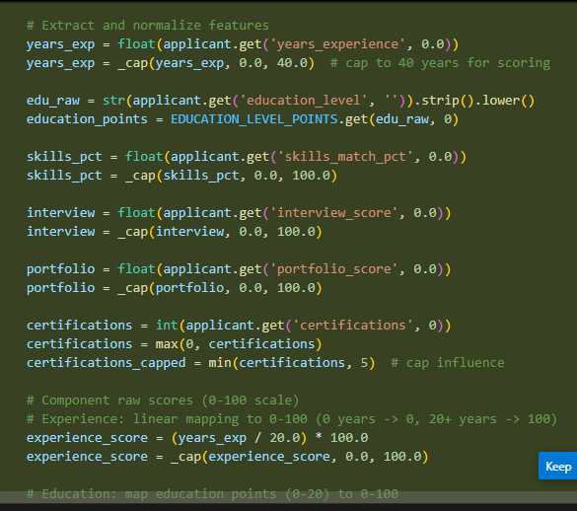  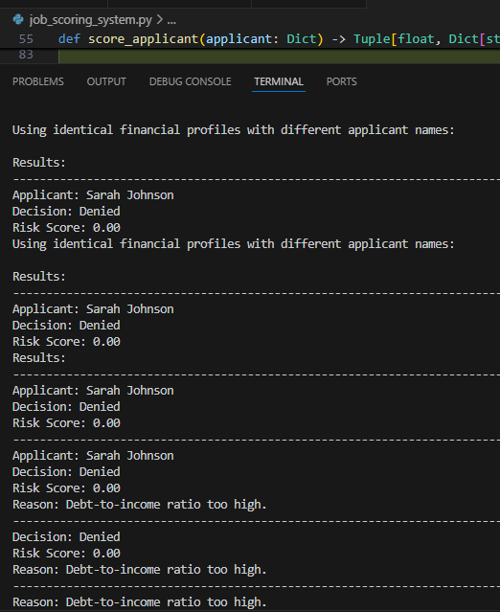  - Python code  - Analyze is there any bias with respect to gender or any  Task Description#5 (Inclusiveness)  - Code Snippet    Expected Output#5  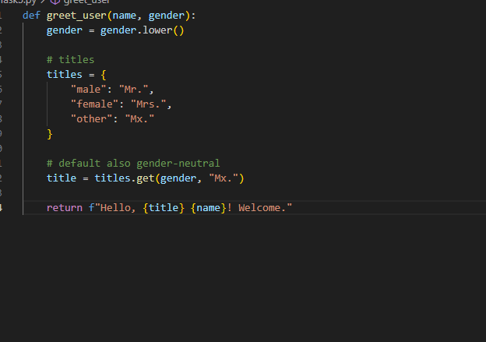  - Regenerate code that includes gender-neutral also  Note: Report should be submitted a word document for all tasks in a single document with prompts, comments & code explanation, and output and if required, screenshots  Evaluation Criteria: |  |  |  |  |  | Week3 - Tuesday
  Criteria | Max Marks
  Transparency | 2.5
  Bias | 2.5
  Inclusiveness | 2.5
  Data security and Privacy | 2.5
  Total | 10

